Ocean Adventure Lab
What is a Marine Mammal?

Time: 12 minutes
Group Size: 10-15 students
Grade Levels: 2nd – 3rd grade
Location: Sahm Marine Education Center (Octo Side)

OVERVIEW OF ACTIVITY

Students will learn the characteristics of a mammal. They will have the opportunity to observe, identify and then sort a variety of animal artifacts and replicas into mammal and non-mammal categories. The mammals will then be sorted further into land (terrestrial) and marine mammal categories.

PERFORMANCE OBJECTIVES

- Given the pictures of the animals and the assistance of the instructor, students will be able to match the picture to the animal artifact to identity the animals they were part of.
- Given a list of the characteristics of a mammal and the identified animal artifacts and replicas, students will be able to sort the animal pictures into mammals and non-mammals.
- Given the definition of land mammals and marine mammals, students will be able to identity the marine mammals.

CHALLENGE

To sort the items on the table into mammal and non-mammal categories.

MATERIALS

- Assorted marine mammal artifacts and replicas
- Selection of terrestrial vertebrate animal artifacts
- Selection of invertebrate animal artifacts
- Marine mammal poster, mammal characteristic poster
- Cards that say: mammal, not a mammal, land mammal, marine mammal
- Pictures of all the animals that artifacts are from
- Copy of the book The Snail and the Whale
- Sea Lion skeleton and Humpback Whale model

ADVANCE PREPARATION

- Set out selection of animal artifacts and replicas, ½ mammals and ½ non-mammals, include both marine and terrestrial mammals. Set out fewer artifacts for a first-grade program.
- Set up posters and cards
PROCEDURE

Engage:
- Do you know that scientists divide animals into different groups according to different characteristics? (define) Does a whale have the same characteristics as a snail? Do you know what type of animal a whale is? (a mammal) Do you know what makes it a mammal? (warm blooded, breath air, have hair, live birth, drink milk) Is a snail a mammal? Why or why not?
Explore:
- “We are going to sort the items on the tables into mammals and non-mammals. First we must have time to look at these items and decide what animals these artifacts are from.” You may need to define artifact in our use of it. Use the Sea Lion skeleton, Humpback Whale model and the Humpback skeleton image on the wall to help the students to understand skeletons.
- Hand each student a picture of an animal to find the artifact that belongs to it. Give instructions on rules to touch the artifacts and how to rotate around the table. Once they have found their animal give them a second card until all cards are gone. There will be a mix of large and small artifacts, and items that cannot be replaced. For these reasons the artifacts should be touched in place and not picked up. We will sort the picture cards not the item themselves.
- Give them time to look at each item and place their picture next to the artifact. Make sure they know what the items are and facilitate as needed. Check for pictures placed on the wrong artifact, pick it up and give it to another student to try.
- Now that we know what the animals are, let’s sort them into two groups. Have the students pick up two cards to sort. Put all the mammal pictures over here next to the card that says Mammals and put all the non-mammals’ pictures over here. Review mammal characteristics as needed.
- Ask why they put a particular animal in one group or other. Make sure they understand the characteristics of mammals. Review characteristics as needed.
- Which of the mammals are marine mammals and which are land mammals? Sort cards if time permits or just point out marine mammals. Define marine mammal as getting their food from the sea.
- Discuss any of the artifacts in more detail.
Explain:
- Comparing a fish artifact to a whale - Why isn’t the whale a fish? What are the characteristics of a fish? (A fish has gills, scales, and is cold blooded. A whale breathes air, has hair, and is warm blooded—a whale is a mammal, just like us!)
- A snail breathes air—does that mean that it is a mammal too? (No, a snail is not a mammal—even though snails, whales and people all breathe air, there are several important characteristics of mammals that snails do not have. Snails don’t have hair, they don’t give live birth, and snails don’t have a backbone. Feel your spine—do you have a backbone? All mammals have skeletons and bones, and animals like snails do not—think of how squishy a snail is—there are no bones in its body! Also, some snails do breathe underwater like fish, and some breathe air and live on land.)
Instructor Self-Evaluation:
1. Were the students able to tell you at least two of the characteristics of a mammal?
2. Could the students explain why a whale is a mammal, and why a snail is not a mammal?

Reminder on artifact handling: Many of these items are irreplaceable. Encourage touching but not picking up the artifacts. Make sure they are gentle and respectful of the items.

BACKGROUND INFO

Mammal Characteristics

All mammals are warm blooded.

Most young are born alive.

They have hair or fur on their bodies.

Every mammal is a vertebrate.

All mammals have lungs to breathe air.

Mammals feed milk to their babies.

Mammal
ANIMAL
WRITTEN BY:
- David M. Armstrong
- J. Knox Jones
- Don E. Wilson
See Article History- https://www.britannica.com/animal/mammal
Alternative Title: Mammalia
Mammal, (class Mammalia), any member of the group of vertebrate animals in which the young are nourished with milk from special mammary glands of the mother. In addition to these characteristic milk glands, mammals are distinguished by several other unique features. Hair is a typical mammalian feature, although in many whales it has disappeared except in the fetal stage. The mammalian lower jaw is hinged directly to the skull, instead of through a separate bone (the quadrate) as in all other vertebrates. A chain of three tiny bones transmits sound waves across the middle ear. A muscular diaphragm separates the heart and the lungs from the abdominal cavity. Only the left aortic arch persists. (In birds the right aortic arch persists; in reptiles, amphibians, and fishes both arches are retained.) Mature red blood cells (erythrocytes) in all mammals lack a nucleus; all other vertebrates have nucleated red blood cells.
Except for the monotremes (an egg-laying order of mammals comprising echidnas and the duck-billed platypus), all mammals are viviparous—they bear live young. In the placental mammals (which have a placenta to facilitate nutrient and waste exchange between the mother and the developing fetus), the young are carried within the mother’s womb, reaching a relatively advanced stage of development before birth. In the marsupials (e.g., kangaroos, opossums, and wallabies), the newborns are incompletely developed at birth and continue to develop outside the womb, attaching themselves to the female’s body in the area of her mammary glands. Some marsupials have a pouchlike structure or fold, the marsupium, that shelters the suckling young.
The class Mammalia is worldwide in distribution. It has been said that mammals have a wider distribution and are more adaptable than any other single class of animals, with the exception of certain less-complex forms such as arachnids and insects. This versatility in exploiting Earth is attributed in large part to the ability of mammals to regulate their body temperatures and internal environment both in excessive heat and aridity and in severe cold.

Diversity
The evolution of the class Mammalia has produced tremendous diversity in form and habit. Living kinds range in size from a bat weighing less than a gram and tiny shrews weighing but a few grams to the largest animal that has ever lived, the Blue Whale, which reaches a length of more than 30 metres (100 feet) and a weight of 180 metric tons (nearly 200 short [U.S.] tons). Every major habitat has been exploited by mammals that swim, fly, run, burrow, glide, or climb.

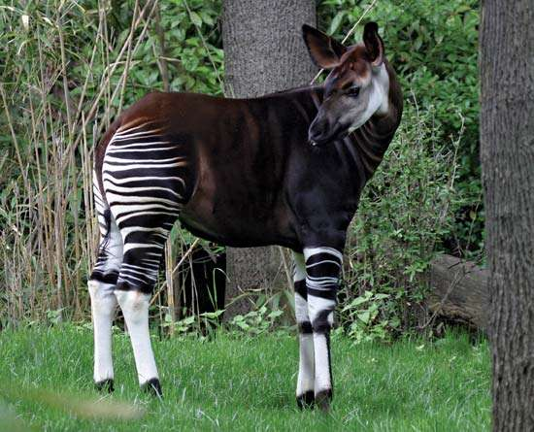
Okapi Okapi (Okapia johnstoni).© Steffen Foerster Photography/Shutterstock.com
There are more than 5,500 species of living mammals, arranged in about 125 families and as many as 27–29 orders (familial and ordinal groupings sometimes vary among authorities). The rodents (order Rodentia) are the most numerous of existing mammals, in both number of species and number of individuals, and are one of the most diverse of living lineages. In contrast, the order Tubulidentata is represented by a single living species, the aardvark. The Uranotheria (elephants and their kin) and Perissodactyla (horses, rhinoceroses, and their kin) are examples of orders in which far greater diversity occurred in the late Paleogene and Neogene periods (about 30 million to about 3 million years ago) than today.
The greatest present-day diversity is seen in continental tropical regions, although members of the class Mammalia live on (or in seas adjacent to) all major landmasses. Mammals can also be found on many oceanic islands, which are principally, but by no means exclusively, inhabited by bats. Major regional faunas can be identified; these resulted in large part from evolution in comparative isolation of stocks of early mammals that reached these areas. South America (the Neotropics), for example, was separated from North America (the Nearctic) from about 65 million to 2.5 million years ago. Mammalian groups that had reached South America before the break between the continents, or some that “island-hopped” after the break, evolved independently from relatives that remained in North America. Some of the latter became extinct as the result of competition with more advanced groups, whereas those in South America flourished, some radiating to the extent that they have successfully competed with invaders since the rejoining of the two continents. Australia provides a parallel case of early isolation and adaptive radiation of mammals (specifically the monotremes and marsupials), although it differs in that Australia was not later connected to any other landmass. The placental mammals that reached Australia (rodents and bats) evidently did so by island-hopping long after the adaptive radiation of the mammals isolated early on.

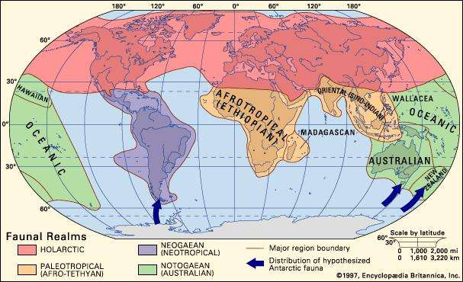
Faunal realms and major regions of the world.Encyclopædia Britannica, Inc.
In contrast, North America and Eurasia (the Palearctic) are separate landmasses but have closely related faunas as the result of having been connected several times during the Pleistocene Epoch (2.6 million to 11,700 years ago) and earlier across the Bering Strait. Their faunas frequently are thought of as representing not two distinct units but one, related to such a degree that a single name, Holarctic, is applied to it.

Natural History
The hallmarks of the mammalian level of organization are advanced reproduction and parental care, behavioral flexibility, and endothermy (the physiological maintenance of a relatively constant body temperature independent of that of the environment, allowing a high level of activity). Within the class, ecological diversity has resulted from adaptive specialization in food acquisition, habitat preferences, and locomotion.

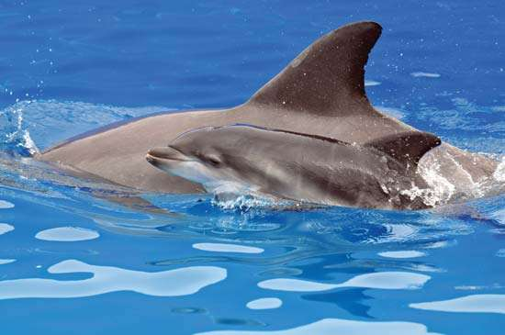
Bottlenose Dolphin A newborn Bottlenose Dolphin calf swimming alongside its mother at SeaWorld amusement park, San Diego, California, 2009.PRNewsFoto/SeaWorld San Diego/AP Images

Throughout the past 66 million years, mammals have been the dominant animals in terrestrial ecosystems and important in nonterrestrial communities as well. The earliest mammals were small, active, predaceous, and terrestrial or semi-arboreal. From this primitive stock mammals have radiated into a wide spectrum of adaptive modes against the background of the diverse-environment of the Cenozoic Era (the last 66 million years). Branches of the ancestral terrestrial stock early exploited the protection and productivity of the trees, whereas other lineages added further dimensions to the mammalian spectrum by adapting to life beneath the ground, in the air, and in marine and freshwater habitats.

